AE351 Experiments in Aerospace Engineering



Experiment-P2

High-speed Flow Visualization using

Shadowgraph and Schlieren technique

(14-2-2020)

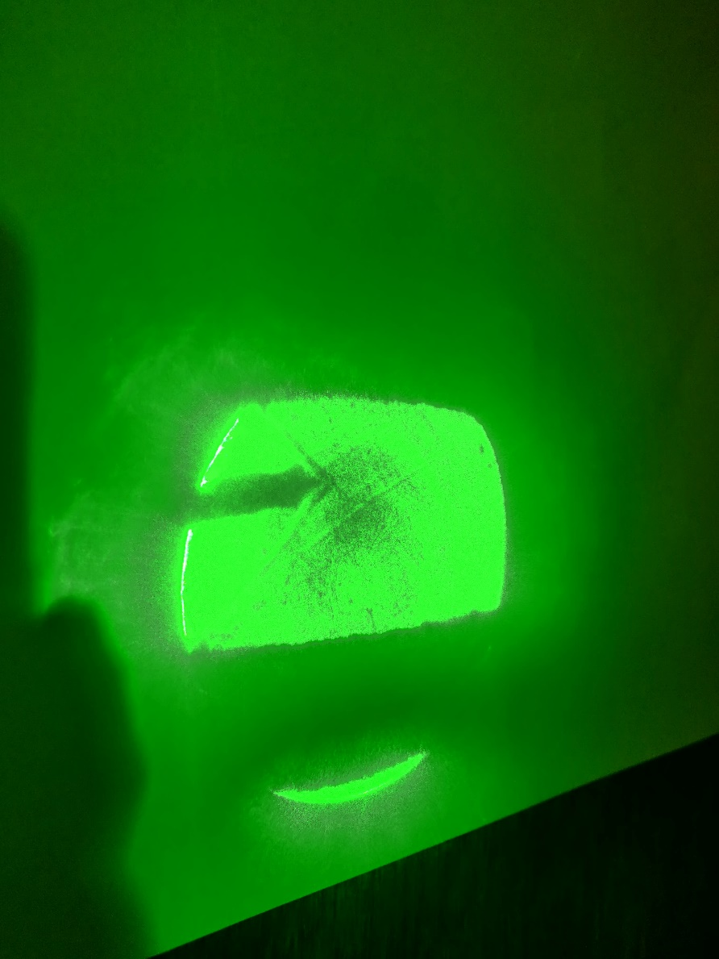

By:

Mataria Pence Jagatkumar

170382 | B9

**OBJECTIVE**

1) To study the shock structure on the solid body using Schlieren visualization technique.

2) To study the shock structure on the solid body using shadowgraph visualization technique.

**INTRODUCTION & THEORY**

* Oblique Shocks

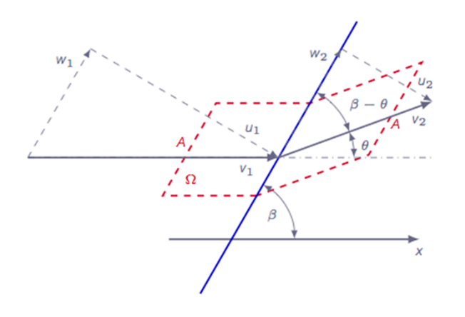The θ−β−M-relation is derived, which proves to be very important in the investigation of oblique shocks. The expression relates the free stream Mach number M, the deflection angle θ, and the oblique shock angle β. From the relation, it is obvious that each situation has two possible solutions one with a lower β angle that is referred to as the weak solution and one with a larger angle β that is referred to as the strong solution. In nature, the weak solution is preferred over the strong solution due to less losses. However, in some cases the strong solution may be the only solution possible due to downstream flow conditions.

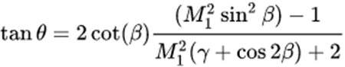The theta-beta-M relation is given by:

* Schlieren Visualization

Schlieren flow visualization is based on the deflection of light by a refractive index gradient. The index gradient is directly proportional to the flow density gradient. The deflected light is compared to undeflected light at a viewing screen. The undisturbed light is partially blocked by a knife edge. The light that is deflected toward or away from the knife edge produces a shadow pattern depending upon whether it was previously blocked or unblocked. This shadow pattern is a light-intensity representation of the expansions (low density regions) and compressions (high density regions) which characterize the flow.

* Shadowgraph Visualization

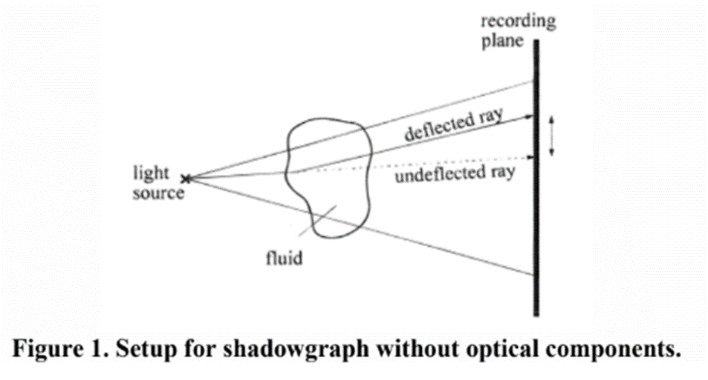The shadowgraph is the simplest form of optical system suitable for observing a flow exhibiting variations of the fluid density. In principle, the system does not need any optical component except a light source and a recording plane onto which to project the shadow of the varying density field. A shadow effect is generated because a light ray is refractively deflected so that the position on the recording plane where the undeflected ray would arrive now remains dark. At the same time the position where the deflected ray arrives appears brighter than the undisturbed environment. A visible pattern of variations of the illumination (contrast) is thereby produced in the recording plane. From an analysis of the optics of the shadow effect it follows that the visible signal depends on the second derivative of the refractive index of the fluid. Therefore, the shadowgraph as an optical diagnostic technique is sensitive to changes of the second derivative of the fluid density.

**EQUIPMENT USED**

* Supersonic Wind tunnel

The schematic of the blowdown tunnel is shown in the figure below. In general, Blowdown tunnels are used to test the models from high subsonic to supersonic flow conditions. De Laval nozzle is used to generate the desired Mach number in the test section. The test section with size 225mm x 175mm is placed at the end of a de Laval nozzle. Basically, the Mach number in the test section is determined by pressure and temperature in the settling chamber and the area ratio between the test sections on the nozzle throat. The test models are fixed in the test section by using a support. The air is pumped into a closed high pressure tank upstream of the settling chamber. At the same time, air is pumped out of a closed low pressure chamber downstream of the test section. As the flow expands in the nozzle, the pressure decreases and any moisture in the tunnel may condense and liquefy in the test section. To avoid condensation, air is brought into the tunnel through a dryer bed. A second throat is used downstream of the test section to shock down the supersonic flow to subsonic before entering the low pressure chamber or silencer.

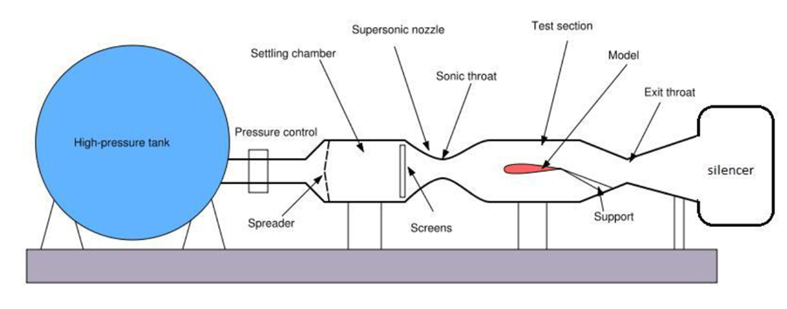

* Nozzle

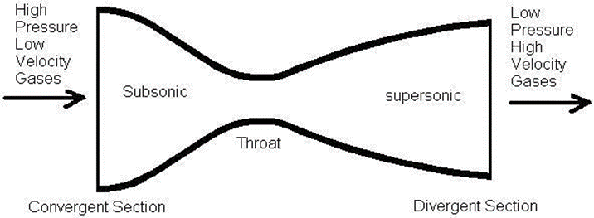The Schematic of de Laval nozzle is as follows:

* Light source and mirrors

5W Laser is used as light source. In general Helium spark arc light source and 150 mm diameter concave mirror is sufficient.

* Electronic pressure scanners

The pitot pressure sensed by the probe was measured using a PSI model 9016, 16- channel pressure transducer. The model 9016 transducer is capable of measuring pressures up to 300 psi, which is approximately 20 atm. The accuracy of the transducer (after re-zero calibration) is specified to be ± 0.15% full scale. Also, transducer offset errors were eliminated by performing a re-zero calibration prior to every run.

* Scanner support module

The application software developed using the LabVIEW links the host computer to the pressure scanner via TCP/IP communication. The application software performs all the required functions like initialize, reset, and re- zero calibration and read pressure.

* Focusing Lens & Knife edge

This lens is positioned in the Schlieren system in such a way that a flow field is focused on the screen. An ordinary double convex is used. Any straight, sharp edged opaque object mounted on an adjustable stand will be sufficient to serve as a knife edge.

**PROCEDURE & MEASUREMENTS**

* Schlieren Visualization

*Illumination of the picture on the screen is proportional to the first derivative of the density*

Familiarize with the general layout and major components of the wind tunnel and Schlieren system. The stagnation pressure (Po), temperature (T0) and nozzle area ratio (A/A*) will determine the Mach number (from isentropic relations) in the test section of wind tunnel. The settling chamber total pressure (Po), maintained constant during a run by controlling the pressure regulating valve. Light from a source is collimated by the first lens and then passed through the test section. It is then brought to a focus by the second lens and projected on the screen. At the focal point of the second lens, where the image of the source is formed, a knife edge is introduced to cut off part of the light. The screen is made to be uniformly illuminated by the portion of the light escaping the knife edge, by suitably adjusting it to intercept about half the light when there is no flow in the test section. The arrangement of Schlieren technique is shown in figure. Obtain the visualized images on the screen for a given Mach number using a camera.

* Shadowgraph Visualization

*Illumination of the picture on the screen is proportional to the second derivative of the density*

Familiarize with the general layout and major components of the wind tunnel and shadowgraph system. The stagnation pressure (Po), temperature (T0) and nozzle area ratio (A/A*) will determine the Mach number (from isentropic relations) in the test section of wind tunnel. The settling chamber total pressure (Po), maintained constant during a run by controlling the pressure regulating valve. The light source was collimated by the condenser lens and then brought to the concave mirror. The parallel beam from the mirror was made to pass through the jet flow field and projected on the screen. The photographs of shadowgraph images of shock-train on the screen were taken directly by using a camera. The arrangement of mirror and light source are shown in Figure. Obtain the visualized images on the screen for a given Mach number using a camera.

**RESULTS & DISCUSSION**

* Initial Observations
  + Height: 10 mm
  + Diameter: 9 mm
  + Half angle = 24.2 deg
* Schlieren Visualization
  + 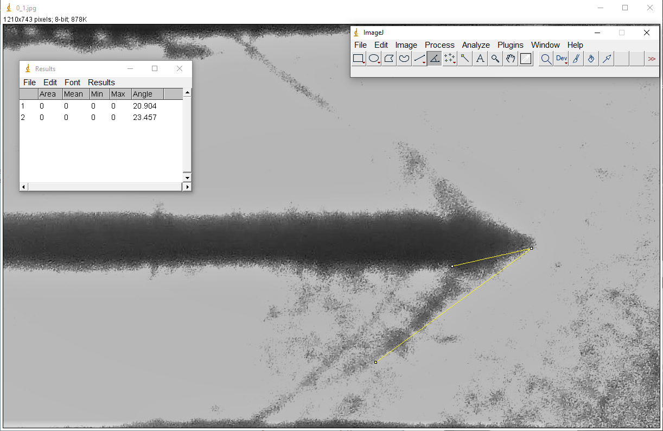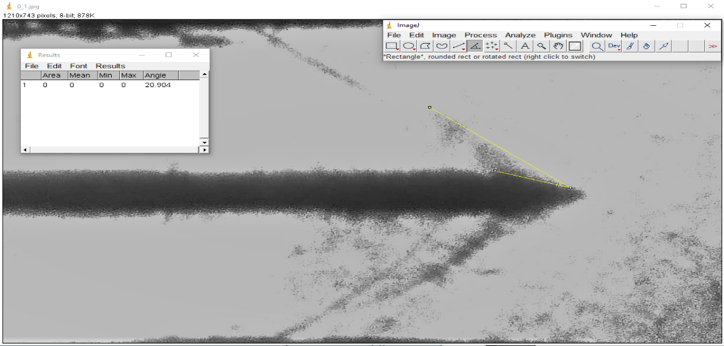α = 0 deg

θ = 24.2 + α = 24.2

Using image analysis, we get angle as;

β - θ = 20.9 deg thus, β = 45.1

Then, using the theta-beta-M relation:

**M1 = 2.78**

Further,

**M2 = 1.626** (mach number of the flow after the shock)

* + α=1.7 deg

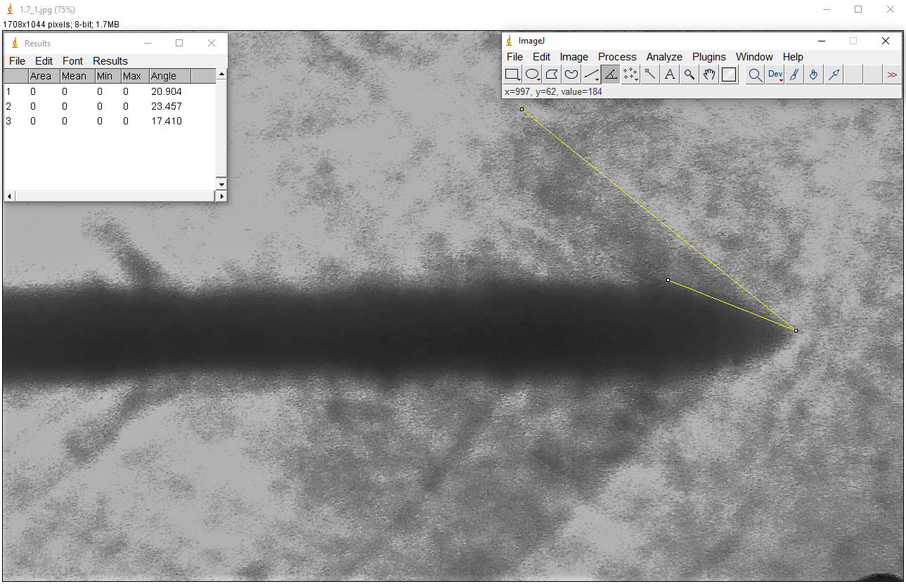 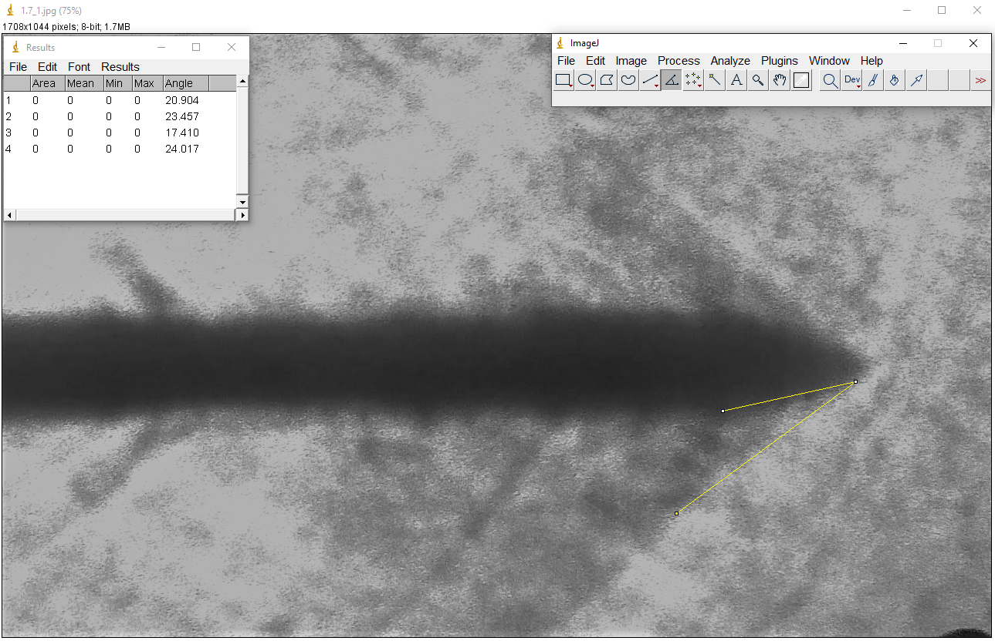

θu = 24.2 + α = 25.9 (for the surface above)

θl = 24.2 - α = 22.5 (for the lower surface)

Using an image analysis, we get the angle as:

βu - θu = 17.1 deg thus, βu = 42 deg

βl - θl = 24 deg thus, βl = 46.5 deg

Then, using the theta-beta-M relation:

**M1 = 2.98** (on an average 2.46,3.5)

Further,

**M2u = 1.911**

**M2l = 1.49**

* + α=2.8 deg

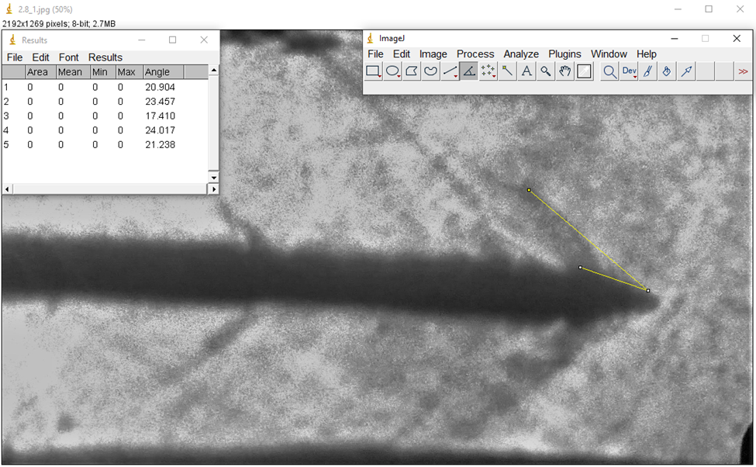

θu = 24.2 + α = 27 (for one surface)

θl = 24.2 - α = 21.4 (for the other surface)

Using an image processing software ImageJ, we get the angle as:

βu - θu = 21.2 deg thus, βu = 48.2 deg

βl - θl = 26.2 deg thus, βl = 47.6 deg

Then, using the theta-beta-M relation:

M1 = 2.8,2.32 => **2.56** (on an average)

Further,

M2u = **1.54**

M2l = **1.43**

* Shadowgraph Visualization
  + α = 0 deg

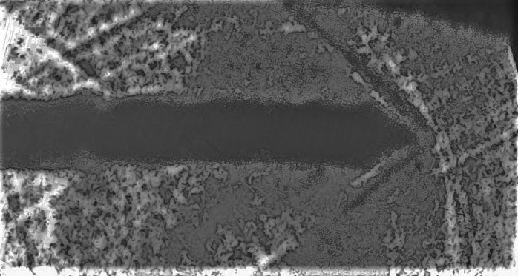

* + α = 1.7 deg

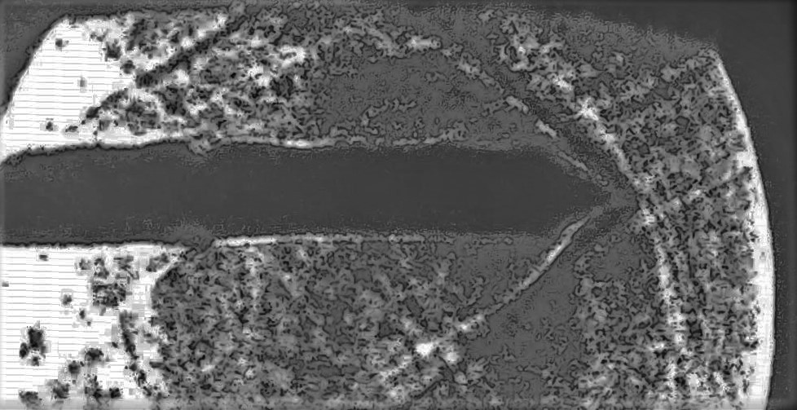

* + α = 2.8 deg

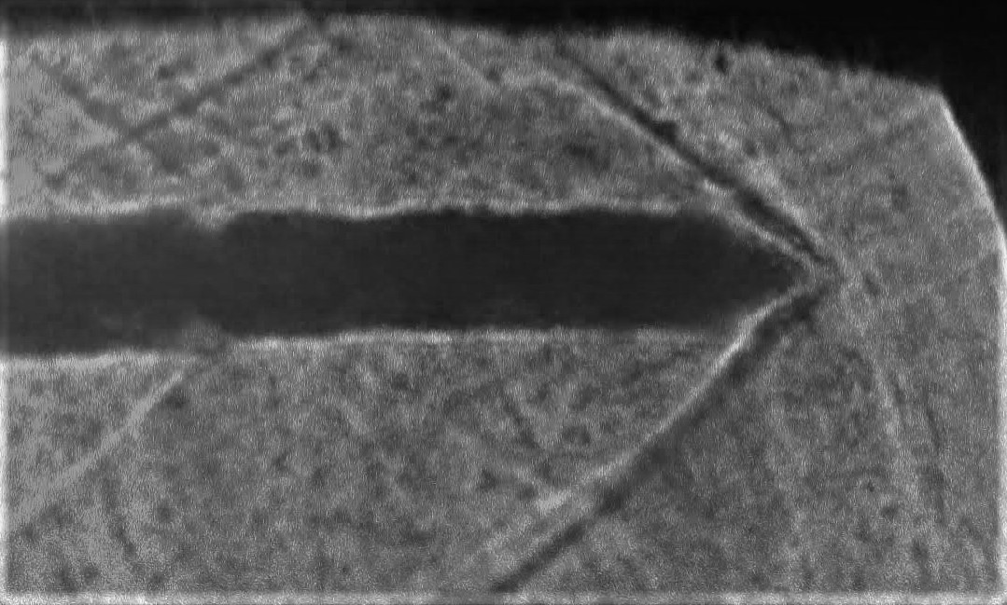

The calculations are similar to Schlieren visualization.

The Mach numbers obtained are:

a) α=0 deg, M = 2.78

b) α=1.7 deg, M = 2.98

c) α=2.8 deg, M = 2.56

**RESULT ANALYSIS**

* Sources of Error
  + Calibration errors
  + Vibrations/oscillations at the object due to disturbances
  + Damaged equipment
  + External light, improper focus
  + Effects of energy loss
  + Inexact oblique shocks, formation of curved shocks instead of straight
  + Camera parallax error
* Precautions
  + In the test section constant conditions need to be provided by controlling a pressure regulator valve.
  + Screen need to be placed close to the test section to have proper visibility of image.
  + Do not block the laser while it is on.

**CONCLUSION**

The experiment was successfully carried out and results resembles true values to certain extent.